Honor Flight of the Cape Fear Area, Inc. (HFCFA) was founded in early 2020 to honor Veterans from southeast North Carolina for their service and sacrifice. HFCFA is one of over 130 “hubs” of the national Honor Flight Network and our mission is to fly Veterans of WWII, and the Korea and Vietnam era Veterans – free of charge – from Wilmington International Airport to Washington DC to visit the monuments and memorials built in their honor.

The Honor Flight effort, which is 100% volunteer-run, includes training of guardians (escorts for the Veterans), chartering an airplane, arranging police-escorted charter buses, securing wheelchairs and oxygen for the Veterans, and providing food and soft drinks throughout the approximately 16- hour day, as well as outfitting the Veterans and guardians with hats, shirts and back-packs filled with items for the day of touring. Our inaugural flight is planned for the fall, of 2021 when we will fly approximately 75 Veterans plus guardians, a medical team, and volunteer staff to our nation’s capital.

How can you help? We can only make this happen with your financial support. Each flight costs approximately $100,000 and is funded by generous donations from local businesses and individuals who want to honor those who have served. Any amount you can donate will be greatly appreciated.

Donations can be made online at: www.HonorFlightCFA.org/donate or sent to the address below. Honor Flight of the Cape Fear Area, Inc. is a 501(c)3 recognized by the Secretary of State of North Carolina as a nonprofit. Donations to HFCFA are tax deductible, as permitted by law.

If you have any questions or would like additional information, please contact Louise McColl at: 910-233-0999.

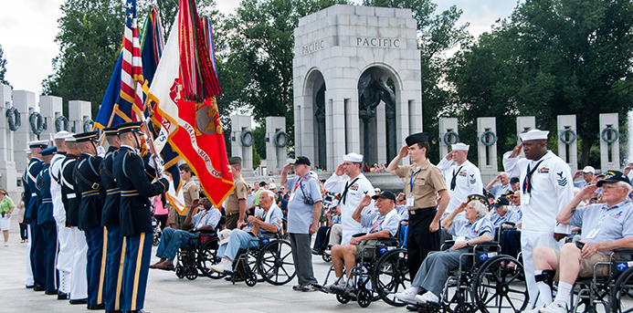
Sincerely,

Louise McColl
Fundraising Leader

“Other than the day I was married and the day my children were born, it was the best day of my life” WWII Veteran who traveled on Honor Flight

